Lenoir City Museum Newsletter – First Quarterly Issue – March 2020
Published by the Lenoir Cotton Mill Association and the Lenoir City Museum
Editor, Beverly Sweeney

Lenoir City Celebrates!
aka I Always Wanted to be a Cover Girl!

In conjunction with Loudon County’s Sesquicentennial Celebration, the Lenoir City Museum has a new exhibit called, “Lenoir City Celebrates.” We will be featuring numerous exhibits starting with the Golden Jubilee in 1957.
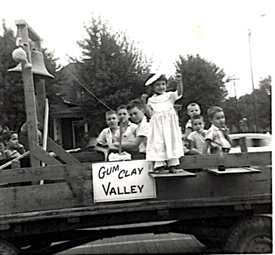
These delightful urchins are my brothers, our neighbors and your editor, Beverly in a 1957 photo from the Golden Jubilee. Period dress? Yes!

The Golden Jubilee was celebrated during the week of August 11-17. Included was a carnival in what is now the parking lot adjacent to the Lenoir City Schools building.

In 1961, Lenoir City celebrated the opening of Fort Loudoun Dam. It is uppermost in a series of dams on the Tennessee River, created to provide flood control, electricity and recreation. The dedication on July 22, 1961 was attended by Speaker of the House, Sam Rayburn, Senators from Tennessee, Estes Kefauver and Albert Gore, Governor Buford Ellington, US Representative Howard Baker and TVA Chairman of the Board Herbert Vogel.
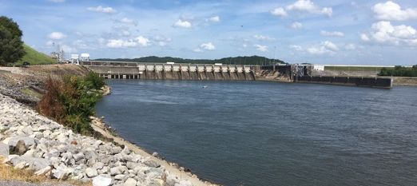
The roadway bridge stayed on top of the dam until
2018, when a new bridge was built downriver.
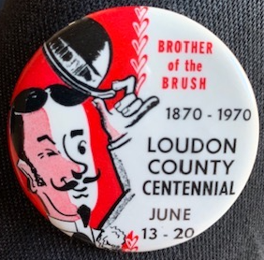
In 1970, Lenoir City helped celebrate Loudon County’s Centennial. Our own Harvey Sproul was County Judge (mayor) at the time. He spearheaded a weeklong celebration that included a pageant, a beard growing contest and more!
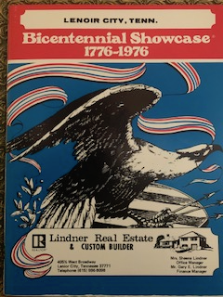

In 1976, Lenoir City celebrated the USA’s Bicentennial with gusto! There was a motor tour of historic homes and churches.

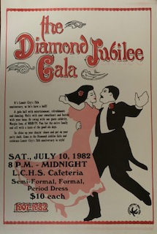

In 1982, Lenoir City celebrated its Diamond Jubilee with a ball and numerous fundraisers to restore the old cotton mill. Knoxville had a World’s Fair event that year, too!
In 1986, the whole state of Tennessee had a party and Lenoir City took it all in, partying with current residents and warmly welcoming returning Lenoir Citians. Our project for the party was working to restore the cotton mill. Later, in 1996, Tennessee celebrated its statehood bicentennial, 1796-1996. Our project for that celebration was the coffee table book, Landmarks of Loudon County.
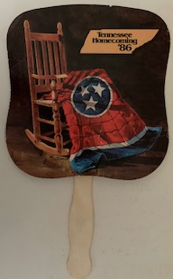
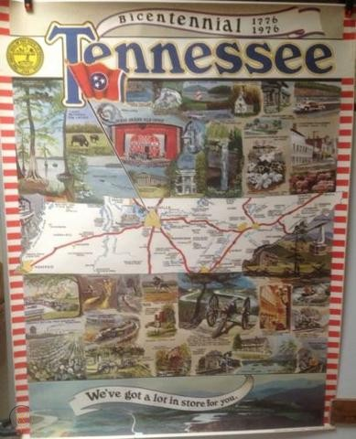

In 2007, Lenoir City celebrated its Centennial in style with a parade and street festival, an art show and sale, and a 1907 Costume Ball.
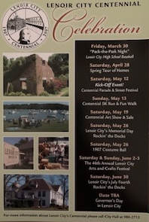

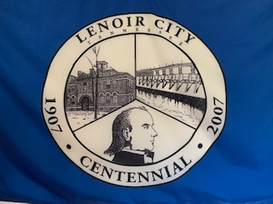

Lenoir City Museum is excited and proud to showcase these festivities. We have programs, videos, still photos, banners, flags and so much more…most importantly, there are additional pictures of your friendly editor on a pony and enjoying the carnival rides in 1957. Come on out to see this exhibit and relive Lenoir City’s festive history.

Were you there for some of these events? Bring your photos to share!

The museum and the exhibit will open for the 2020 season on April 1, 2020. The party starts at noon with a ribbon cutting ceremony in conjunction with the Loudon County Chamber of Commerce. This is an easy date to remember and you would be FOOLISH not to come.

Lenoir City Museum is open Wednesday through Friday from 1-4PM, from April through October
110 Depot Street, Lenoir City, TN 37771;
for an appointment during the off-season,
call 865-986-9169

Walking tours of downtown by appointment and in conjunction with city events, such as Spring Fling in April, the Street Festival and Car Show in August and the Harvest Festival in October.
See you there!

lenoircitymuseum@yahoo.com;
@lenoirmuseum; www.facebook.com/LenoirCityMuseum; www.lenoircitymerchants.com/lenoircitymuseum

